### Managing Panel Schedules

Power circuits can only be connected to a compatible panel. The panel being selected for connection must have a slot available and must match the distribution system for the circuit being connected. To add a circuit to a panel, highlight a component in a circuit and edit the circuit. Select a panel from the Panel drop-down list to connect the circuit to a panel.

Panel Schedules are automatically populated based on the connected electrical equipment, devices, and fixtures. The Panel Schedule Template applied to a panelboard can be changed after it has been created, but any notes or data specific to the original template that is not stored in parameter fields will be lost after switching to a new Panel Schedule Template. When a panel schedule is displayed the circuits can be rearranged on the panel by moving them up, down, left, or right. The panel load can also be balanced across phases, spares or spaces can be assigned, and circuit names can be edited directly in the panel schedule.

As new projects bring new requirements, the Panel Schedule Templates should be updated, and new Panel Schedule Templates should be created to suit the new project needs. It is best practice to duplicate existing panel schedule templates and modify as needed to expedite the process rather than create a new template from scratch.

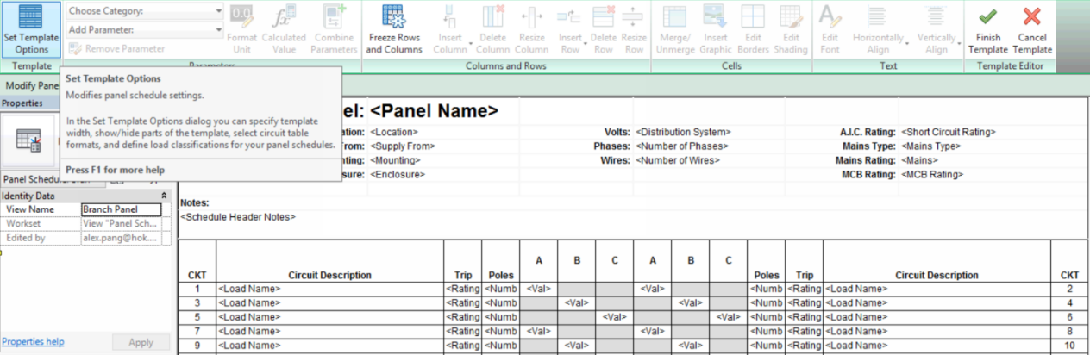

Figure 6.4‑2 Panel Schedule Template icon location

If a non-standard Panel Schedule is required, the Revit Coordinator should be notified. The panel schedule should be added on a project basis and the Panel Schedule should not be stored in the SFO Revit template file. It is useful to flag non-standard Panel Schedule(s) so they may be easily identified by other electrical team members.

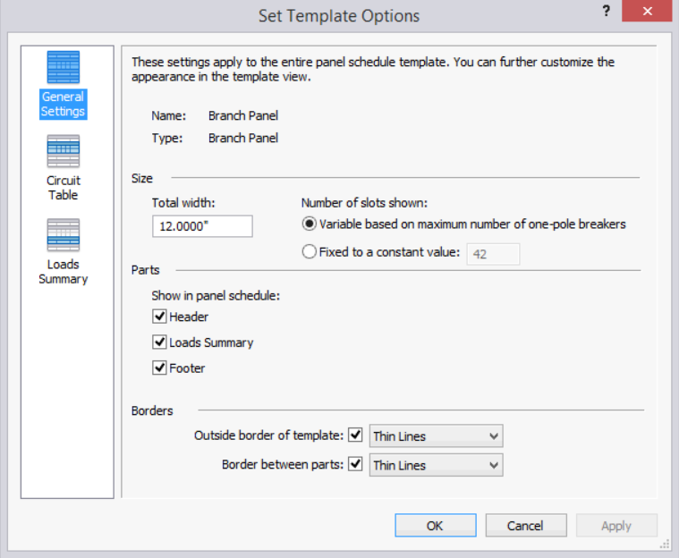

Figure 6.4‑3 Template Options